

A | B | C | D | E | F | G | H | I | J | K | L | M | N | O | P | Q | R | S | T | U | V | W | X | Y | Z | @& | =_^.,"' | +% | !?/ | $£ | 1-10
pg  1 | pg  2 | pg  3 | pg  4 | pg  5 | pg  6 | pg  7 | pg  8 | pg  9 | pg  10 | pg  11 | pg  12 | pg  13 | pg  14 | pg  15 | pg  16 | pg  17 | pg  18 | pg  19 | pg  20 | pg  21 | pg  22 | pg  23 | pg  24 | pg  25 | pg  26 | pg  27 | pg  28 | pg  29 | pg  30 | pg  31 | pg  32-36



A | B | C | D | E | F | G | H | I | J | K | L | M | N | O | P | Q | R | S | T | U | V | W | X | Y | Z | @& | =_^.,"' | +% | !?/ | $£ | 1-10
pg  1 | pg  2 | pg  3 | pg  4 | pg  5 | pg  6 | pg  7 | pg  8 | pg  9 | pg  10 | pg  11 | pg  12 | pg  13 | pg  14 | pg  15 | pg  16 | pg  17 | pg  18 | pg  19 | pg  20 | pg  21 | pg  22 | pg  23 | pg  24 | pg  25 | pg  26 | pg  27 | pg  28 | pg  29 | pg  30 | pg  31 | pg  32-36



A | B | C | D | E | F | G | H | I | J | K | L | M | N | O | P | Q | R | S | T | U | V | W | X | Y | Z | @& | =_^.,"' | +% | !?/ | $£ | 1-10
pg  1 | pg  2 | pg  3 | pg  4 | pg  5 | pg  6 | pg  7 | pg  8 | pg  9 | pg  10 | pg  11 | pg  12 | pg  13 | pg  14 | pg  15 | pg  16 | pg  17 | pg  18 | pg  19 | pg  20 | pg  21 | pg  22 | pg  23 | pg  24 | pg  25 | pg  26 | pg  27 | pg  28 | pg  29 | pg  30 | pg  31 | pg  32-36



A | B | C | D | E | F | G | H | I | J | K | L | M | N | O | P | Q | R | S | T | U | V | W | X | Y | Z | @& | =_^.,"' | +% | !?/ | $£ | 1-10
pg  1 | pg  2 | pg  3 | pg  4 | pg  5 | pg  6 | pg  7 | pg  8 | pg  9 | pg  10 | pg  11 | pg  12 | pg  13 | pg  14 | pg  15 | pg  16 | pg  17 | pg  18 | pg  19 | pg  20 | pg  21 | pg  22 | pg  23 | pg  24 | pg  25 | pg  26 | pg  27 | pg  28 | pg  29 | pg  30 | pg  31 | pg  32-36



A | B | C | D | E | F | G | H | I | J | K | L | M | N | O | P | Q | R | S | T | U | V | W | X | Y | Z | @& | =_^.,"' | +% | !?/ | $£ | 1-10
pg  1 | pg  2 | pg  3 | pg  4 | pg  5 | pg  6 | pg  7 | pg  8 | pg  9 | pg  10 | pg  11 | pg  12 | pg  13 | pg  14 | pg  15 | pg  16 | pg  17 | pg  18 | pg  19 | pg  20 | pg  21 | pg  22 | pg  23 | pg  24 | pg  25 | pg  26 | pg  27 | pg  28 | pg  29 | pg  30 | pg  31 | pg  32-36



A | B | C | D | E | F | G | H | I | J | K | L | M | N | O | P | Q | R | S | T | U | V | W | X | Y | Z | @& | =_^.,"' | +% | !?/ | $£ | 1-10
pg  1 | pg  2 | pg  3 | pg  4 | pg  5 | pg  6 | pg  7 | pg  8 | pg  9 | pg  10 | pg  11 | pg  12 | pg  13 | pg  14 | pg  15 | pg  16 | pg  17 | pg  18 | pg  19 | pg  20 | pg  21 | pg  22 | pg  23 | pg  24 | pg  25 | pg  26 | pg  27 | pg  28 | pg  29 | pg  30 | pg  31 | pg  32-36



A | B | C | D | E | F | G | H | I | J | K | L | M | N | O | P | Q | R | S | T | U | V | W | X | Y | Z | @& | =_^.,"' | +% | !?/ | $£ | 1-10
pg  1 | pg  2 | pg  3 | pg  4 | pg  5 | pg  6 | pg  7 | pg  8 | pg  9 | pg  10 | pg  11 | pg  12 | pg  13 | pg  14 | pg  15 | pg  16 | pg  17 | pg  18 | pg  19 | pg  20 | pg  21 | pg  22 | pg  23 | pg  24 | pg  25 | pg  26 | pg  27 | pg  28 | pg  29 | pg  30 | pg  31 | pg  32-36



A | B | C | D | E | F | G | H | I | J | K | L | M | N | O | P | Q | R | S | T | U | V | W | X | Y | Z | @& | =_^.,"' | +% | !?/ | $£ | 1-10
pg  1 | pg  2 | pg  3 | pg  4 | pg  5 | pg  6 | pg  7 | pg  8 | pg  9 | pg  10 | pg  11 | pg  12 | pg  13 | pg  14 | pg  15 | pg  16 | pg  17 | pg  18 | pg  19 | pg  20 | pg  21 | pg  22 | pg  23 | pg  24 | pg  25 | pg  26 | pg  27 | pg  28 | pg  29 | pg  30 | pg  31 | pg  32-36



A | B | C | D | E | F | G | H | I | J | K | L | M | N | O | P | Q | R | S | T | U | V | W | X | Y | Z | @& | =_^.,"' | +% | !?/ | $£ | 1-10
pg  1 | pg  2 | pg  3 | pg  4 | pg  5 | pg  6 | pg  7 | pg  8 | pg  9 | pg  10 | pg  11 | pg  12 | pg  13 | pg  14 | pg  15 | pg  16 | pg  17 | pg  18 | pg  19 | pg  20 | pg  21 | pg  22 | pg  23 | pg  24 | pg  25 | pg  26 | pg  27 | pg  28 | pg  29 | pg  30 | pg  31 | pg  32-36
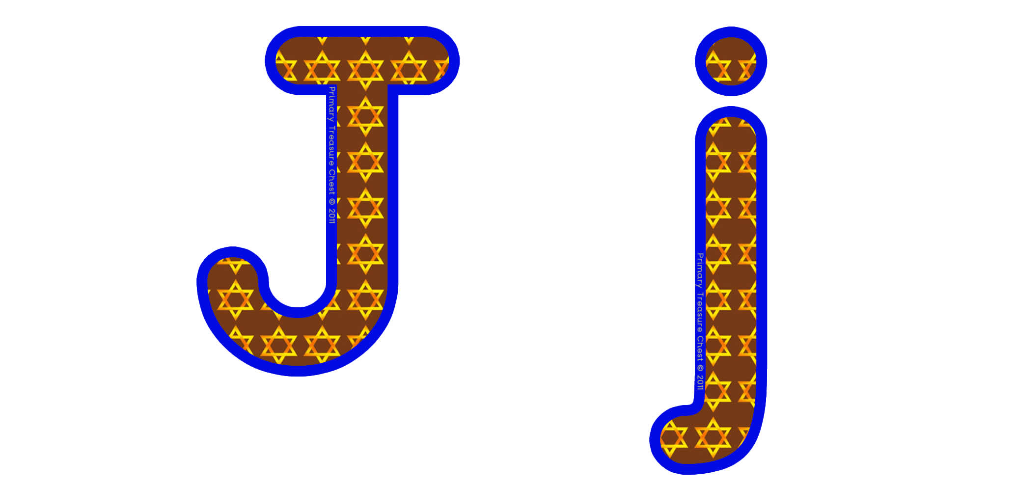

A | B | C | D | E | F | G | H | I | J | K | L | M | N | O | P | Q | R | S | T | U | V | W | X | Y | Z | @& | =_^.,"' | +% | !?/ | $£ | 1-10
pg  1 | pg  2 | pg  3 | pg  4 | pg  5 | pg  6 | pg  7 | pg  8 | pg  9 | pg  10 | pg  11 | pg  12 | pg  13 | pg  14 | pg  15 | pg  16 | pg  17 | pg  18 | pg  19 | pg  20 | pg  21 | pg  22 | pg  23 | pg  24 | pg  25 | pg  26 | pg  27 | pg  28 | pg  29 | pg  30 | pg  31 | pg  32-36



A | B | C | D | E | F | G | H | I | J | K | L | M | N | O | P | Q | R | S | T | U | V | W | X | Y | Z | @& | =_^.,"' | +% | !?/ | $£ | 1-10
pg  1 | pg  2 | pg  3 | pg  4 | pg  5 | pg  6 | pg  7 | pg  8 | pg  9 | pg  10 | pg  11 | pg  12 | pg  13 | pg  14 | pg  15 | pg  16 | pg  17 | pg  18 | pg  19 | pg  20 | pg  21 | pg  22 | pg  23 | pg  24 | pg  25 | pg  26 | pg  27 | pg  28 | pg  29 | pg  30 | pg  31 | pg  32-36



A | B | C | D | E | F | G | H | I | J | K | L | M | N | O | P | Q | R | S | T | U | V | W | X | Y | Z | @& | =_^.,"' | +% | !?/ | $£ | 1-10
pg  1 | pg  2 | pg  3 | pg  4 | pg  5 | pg  6 | pg  7 | pg  8 | pg  9 | pg  10 | pg  11 | pg  12 | pg  13 | pg  14 | pg  15 | pg  16 | pg  17 | pg  18 | pg  19 | pg  20 | pg  21 | pg  22 | pg  23 | pg  24 | pg  25 | pg  26 | pg  27 | pg  28 | pg  29 | pg  30 | pg  31 | pg  32-36



A | B | C | D | E | F | G | H | I | J | K | L | M | N | O | P | Q | R | S | T | U | V | W | X | Y | Z | @& | =_^.,"' | +% | !?/ | $£ | 1-10
pg  1 | pg  2 | pg  3 | pg  4 | pg  5 | pg  6 | pg  7 | pg  8 | pg  9 | pg  10 | pg  11 | pg  12 | pg  13 | pg  14 | pg  15 | pg  16 | pg  17 | pg  18 | pg  19 | pg  20 | pg  21 | pg  22 | pg  23 | pg  24 | pg  25 | pg  26 | pg  27 | pg  28 | pg  29 | pg  30 | pg  31 | pg  32-36



A | B | C | D | E | F | G | H | I | J | K | L | M | N | O | P | Q | R | S | T | U | V | W | X | Y | Z | @& | =_^.,"' | +% | !?/ | $£ | 1-10
pg  1 | pg  2 | pg  3 | pg  4 | pg  5 | pg  6 | pg  7 | pg  8 | pg  9 | pg  10 | pg  11 | pg  12 | pg  13 | pg  14 | pg  15 | pg  16 | pg  17 | pg  18 | pg  19 | pg  20 | pg  21 | pg  22 | pg  23 | pg  24 | pg  25 | pg  26 | pg  27 | pg  28 | pg  29 | pg  30 | pg  31 | pg  32-36



A | B | C | D | E | F | G | H | I | J | K | L | M | N | O | P | Q | R | S | T | U | V | W | X | Y | Z | @& | =_^.,"' | +% | !?/ | $£ | 1-10
pg  1 | pg  2 | pg  3 | pg  4 | pg  5 | pg  6 | pg  7 | pg  8 | pg  9 | pg  10 | pg  11 | pg  12 | pg  13 | pg  14 | pg  15 | pg  16 | pg  17 | pg  18 | pg  19 | pg  20 | pg  21 | pg  22 | pg  23 | pg  24 | pg  25 | pg  26 | pg  27 | pg  28 | pg  29 | pg  30 | pg  31 | pg  32-36


A | B | C | D | E | F | G | H | I | J | K | L | M | N | O | P | Q | R | S | T | U | V | W | X | Y | Z | @& | =_^.,"' | +% | !?/ | $£ | 1-10
pg  1 | pg  2 | pg  3 | pg  4 | pg  5 | pg  6 | pg  7 | pg  8 | pg  9 | pg  10 | pg  11 | pg  12 | pg  13 | pg  14 | pg  15 | pg  16 | pg  17 | pg  18 | pg  19 | pg  20 | pg  21 | pg  22 | pg  23 | pg  24 | pg  25 | pg  26 | pg  27 | pg  28 | pg  29 | pg  30 | pg  31 | pg  32-36



A | B | C | D | E | F | G | H | I | J | K | L | M | N | O | P | Q | R | S | T | U | V | W | X | Y | Z | @& | =_^.,"' | +% | !?/ | $£ | 1-10
pg  1 | pg  2 | pg  3 | pg  4 | pg  5 | pg  6 | pg  7 | pg  8 | pg  9 | pg  10 | pg  11 | pg  12 | pg  13 | pg  14 | pg  15 | pg  16 | pg  17 | pg  18 | pg  19 | pg  20 | pg  21 | pg  22 | pg  23 | pg  24 | pg  25 | pg  26 | pg  27 | pg  28 | pg  29 | pg  30 | pg  31 | pg  32-36



A | B | C | D | E | F | G | H | I | J | K | L | M | N | O | P | Q | R | S | T | U | V | W | X | Y | Z | @& | =_^.,"' | +% | !?/ | $£ | 1-10
pg  1 | pg  2 | pg  3 | pg  4 | pg  5 | pg  6 | pg  7 | pg  8 | pg  9 | pg  10 | pg  11 | pg  12 | pg  13 | pg  14 | pg  15 | pg  16 | pg  17 | pg  18 | pg  19 | pg  20 | pg  21 | pg  22 | pg  23 | pg  24 | pg  25 | pg  26 | pg  27 | pg  28 | pg  29 | pg  30 | pg  31 | pg  32-36



A | B | C | D | E | F | G | H | I | J | K | L | M | N | O | P | Q | R | S | T | U | V | W | X | Y | Z | @& | =_^.,"' | +% | !?/ | $£ | 1-10
pg  1 | pg  2 | pg  3 | pg  4 | pg  5 | pg  6 | pg  7 | pg  8 | pg  9 | pg  10 | pg  11 | pg  12 | pg  13 | pg  14 | pg  15 | pg  16 | pg  17 | pg  18 | pg  19 | pg  20 | pg  21 | pg  22 | pg  23 | pg  24 | pg  25 | pg  26 | pg  27 | pg  28 | pg  29 | pg  30 | pg  31 | pg  32-36



A | B | C | D | E | F | G | H | I | J | K | L | M | N | O | P | Q | R | S | T | U | V | W | X | Y | Z | @& | =_^.,"' | +% | !?/ | $£ | 1-10
pg  1 | pg  2 | pg  3 | pg  4 | pg  5 | pg  6 | pg  7 | pg  8 | pg  9 | pg  10 | pg  11 | pg  12 | pg  13 | pg  14 | pg  15 | pg  16 | pg  17 | pg  18 | pg  19 | pg  20 | pg  21 | pg  22 | pg  23 | pg  24 | pg  25 | pg  26 | pg  27 | pg  28 | pg  29 | pg  30 | pg  31 | pg  32-36



A | B | C | D | E | F | G | H | I | J | K | L | M | N | O | P | Q | R | S | T | U | V | W | X | Y | Z | @& | =_^.,"' | +% | !?/ | $£ | 1-10
pg  1 | pg  2 | pg  3 | pg  4 | pg  5 | pg  6 | pg  7 | pg  8 | pg  9 | pg  10 | pg  11 | pg  12 | pg  13 | pg  14 | pg  15 | pg  16 | pg  17 | pg  18 | pg  19 | pg  20 | pg  21 | pg  22 | pg  23 | pg  24 | pg  25 | pg  26 | pg  27 | pg  28 | pg  29 | pg  30 | pg  31 | pg  32-36



A | B | C | D | E | F | G | H | I | J | K | L | M | N | O | P | Q | R | S | T | U | V | W | X | Y | Z | @& | =_^.,"' | +% | !?/ | $£ | 1-10
pg  1 | pg  2 | pg  3 | pg  4 | pg  5 | pg  6 | pg  7 | pg  8 | pg  9 | pg  10 | pg  11 | pg  12 | pg  13 | pg  14 | pg  15 | pg  16 | pg  17 | pg  18 | pg  19 | pg  20 | pg  21 | pg  22 | pg  23 | pg  24 | pg  25 | pg  26 | pg  27 | pg  28 | pg  29 | pg  30 | pg  31 | pg  32-36



A | B | C | D | E | F | G | H | I | J | K | L | M | N | O | P | Q | R | S | T | U | V | W | X | Y | Z | @& | =_^.,"' | +% | !?/ | $£ | 1-10
pg  1 | pg  2 | pg  3 | pg  4 | pg  5 | pg  6 | pg  7 | pg  8 | pg  9 | pg  10 | pg  11 | pg  12 | pg  13 | pg  14 | pg  15 | pg  16 | pg  17 | pg  18 | pg  19 | pg  20 | pg  21 | pg  22 | pg  23 | pg  24 | pg  25 | pg  26 | pg  27 | pg  28 | pg  29 | pg  30 | pg  31 | pg  32-36



A | B | C | D | E | F | G | H | I | J | K | L | M | N | O | P | Q | R | S | T | U | V | W | X | Y | Z | @& | =_^.,"' | +% | !?/ | $£ | 1-10
pg  1 | pg  2 | pg  3 | pg  4 | pg  5 | pg  6 | pg  7 | pg  8 | pg  9 | pg  10 | pg  11 | pg  12 | pg  13 | pg  14 | pg  15 | pg  16 | pg  17 | pg  18 | pg  19 | pg  20 | pg  21 | pg  22 | pg  23 | pg  24 | pg  25 | pg  26 | pg  27 | pg  28 | pg  29 | pg  30 | pg  31 | pg  32-36




A | B | C | D | E | F | G | H | I | J | K | L | M | N | O | P | Q | R | S | T | U | V | W | X | Y | Z | @& | =_^.,"' | +% | !?/ | $£ | 1-10
pg  1 | pg  2 | pg  3 | pg  4 | pg  5 | pg  6 | pg  7 | pg  8 | pg  9 | pg  10 | pg  11 | pg  12 | pg  13 | pg  14 | pg  15 | pg  16 | pg  17 | pg  18 | pg  19 | pg  20 | pg  21 | pg  22 | pg  23 | pg  24 | pg  25 | pg  26 | pg  27 | pg  28 | pg  29 | pg  30 | pg  31 | pg  32-36

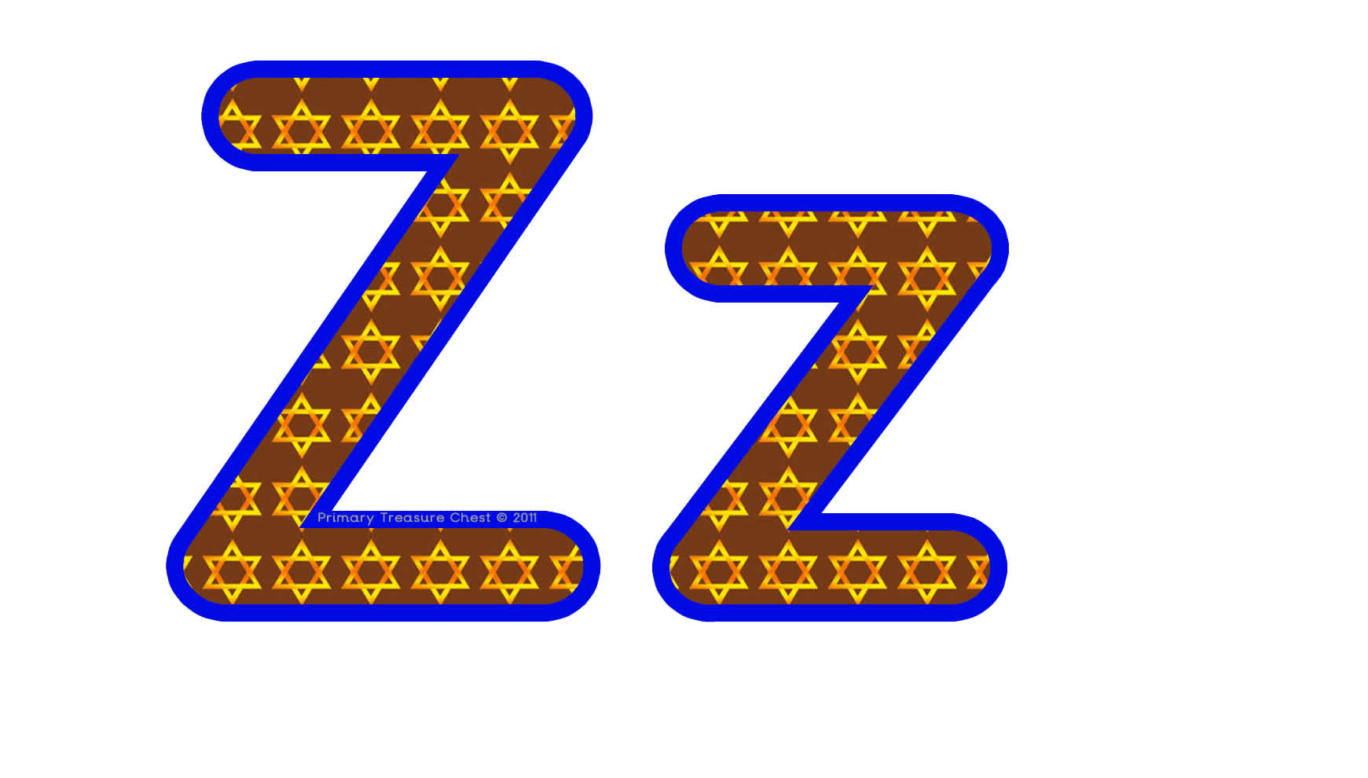

A | B | C | D | E | F | G | H | I | J | K | L | M | N | O | P | Q | R | S | T | U | V | W | X | Y | Z | @& | =_^.,"' | +% | !?/ | $£ | 1-10
pg  1 | pg  2 | pg  3 | pg  4 | pg  5 | pg  6 | pg  7 | pg  8 | pg  9 | pg  10 | pg  11 | pg  12 | pg  13 | pg  14 | pg  15 | pg  16 | pg  17 | pg  18 | pg  19 | pg  20 | pg  21 | pg  22 | pg  23 | pg  24 | pg  25 | pg  26 | pg  27 | pg  28 | pg  29 | pg  30 | pg  31 | pg  32-36



A | B | C | D | E | F | G | H | I | J | K | L | M | N | O | P | Q | R | S | T | U | V | W | X | Y | Z | @& | =_^.,"' | +% | !?/ | $£ | 1-10
pg  1 | pg  2 | pg  3 | pg  4 | pg  5 | pg  6 | pg  7 | pg  8 | pg  9 | pg  10 | pg  11 | pg  12 | pg  13 | pg  14 | pg  15 | pg  16 | pg  17 | pg  18 | pg  19 | pg  20 | pg  21 | pg  22 | pg  23 | pg  24 | pg  25 | pg  26 | pg  27 | pg  28 | pg  29 | pg  30 | pg  31 | pg  32-36


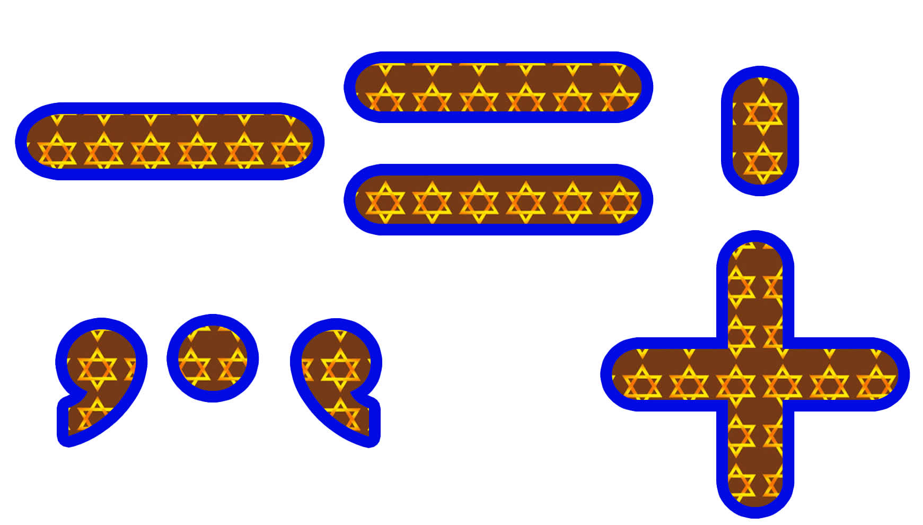

A | B | C | D | E | F | G | H | I | J | K | L | M | N | O | P | Q | R | S | T | U | V | W | X | Y | Z | @& | =_^.,"' | +% | !?/ | $£ | 1-10
pg  1 | pg  2 | pg  3 | pg  4 | pg  5 | pg  6 | pg  7 | pg  8 | pg  9 | pg  10 | pg  11 | pg  12 | pg  13 | pg  14 | pg  15 | pg  16 | pg  17 | pg  18 | pg  19 | pg  20 | pg  21 | pg  22 | pg  23 | pg  24 | pg  25 | pg  26 | pg  27 | pg  28 | pg  29 | pg  30 | pg  31 | pg  32-36


A | B | C | D | E | F | G | H | I | J | K | L | M | N | O | P | Q | R | S | T | U | V | W | X | Y | Z | @& | =_^.,"' | +% | !?/ | $£ | 1-10
pg  1 | pg  2 | pg  3 | pg  4 | pg  5 | pg  6 | pg  7 | pg  8 | pg  9 | pg  10 | pg  11 | pg  12 | pg  13 | pg  14 | pg  15 | pg  16 | pg  17 | pg  18 | pg  19 | pg  20 | pg  21 | pg  22 | pg  23 | pg  24 | pg  25 | pg  26 | pg  27 | pg  28 | pg  29 | pg  30 | pg  31 | pg  32-36



A | B | C | D | E | F | G | H | I | J | K | L | M | N | O | P | Q | R | S | T | U | V | W | X | Y | Z | @& | =_^.,"' | +% | !?/ | $£
pg  1 | pg  2 | pg  3 | pg  4 | pg  5 | pg  6 | pg  7 | pg  8 | pg  9 | pg  10 | pg  11 | pg  12 | pg  13 | pg  14 | pg  15 | pg  16 | pg  17 | pg  18 | pg  19 | pg  20 | pg  21 | pg  22 | pg  23 | pg  24 | pg  25 | pg  26 | pg  27 | pg  28 | pg  29 | pg  30 | pg  31




A | B | C | D | E | F | G | H | I | J | K | L | M | N | O | P | Q | R | S | T | U | V | W | X | Y | Z | @& | =_^.,"' | +% | !?/ | $£
pg  1 | pg  2 | pg  3 | pg  4 | pg  5 | pg  6 | pg  7 | pg  8 | pg  9 | pg  10 | pg  11 | pg  12 | pg  13 | pg  14 | pg  15 | pg  16 | pg  17 | pg  18 | pg  19 | pg  20 | pg  21 | pg  22 | pg  23 | pg  24 | pg  25 | pg  26 | pg  27 | pg  28 | pg  29 | pg  30 | pg  31




A | B | C | D | E | F | G | H | I | J | K | L | M | N | O | P | Q | R | S | T | U | V | W | X | Y | Z | @& | =_^.,"' | +% | !?/ | $£ | 1-10
pg  1 | pg  2 | pg  3 | pg  4 | pg  5 | pg  6 | pg  7 | pg  8 | pg  9 | pg  10 | pg  11 | pg  12 | pg  13 | pg  14 | pg  15 | pg  16 | pg  17 | pg  18 | pg  19 | pg  20 | pg  21 | pg  22 | pg  23 | pg  24 | pg  25 | pg  26 | pg  27 | pg  28 | pg  29 | pg  30 | pg  31 | pg  32-36

A | B | C | D | E | F | G | H | I | J | K | L | M | N | O | P | Q | R | S | T | U | V | W | X | Y | Z | @& | =_^.,"' | +% | !?/ | $£ | 1-10
pg  1 | pg  2 | pg  3 | pg  4 | pg  5 | pg  6 | pg  7 | pg  8 | pg  9 | pg  10 | pg  11 | pg  12 | pg  13 | pg  14 | pg  15 | pg  16 | pg  17 | pg  18 | pg  19 | pg  20 | pg  21 | pg  22 | pg  23 | pg  24 | pg  25 | pg  26 | pg  27 | pg  28 | pg  29 | pg  30 | pg  31 | pg  32-36

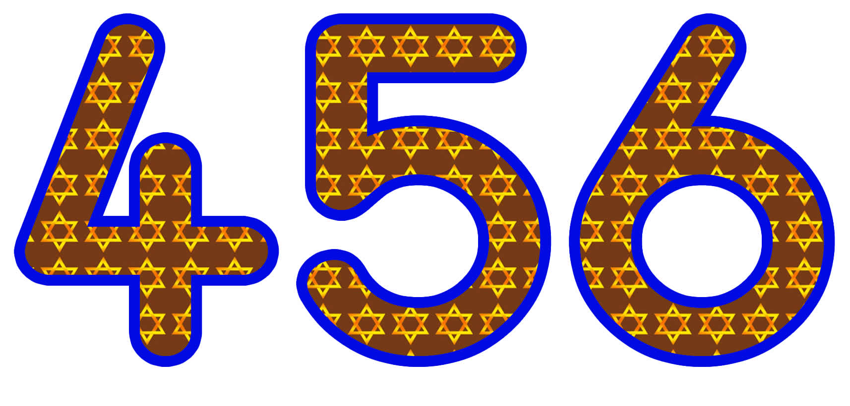

A | B | C | D | E | F | G | H | I | J | K | L | M | N | O | P | Q | R | S | T | U | V | W | X | Y | Z | @& | =_^.,"' | +% | !?/ | $£ | 1-10
pg  1 | pg  2 | pg  3 | pg  4 | pg  5 | pg  6 | pg  7 | pg  8 | pg  9 | pg  10 | pg  11 | pg  12 | pg  13 | pg  14 | pg  15 | pg  16 | pg  17 | pg  18 | pg  19 | pg  20 | pg  21 | pg  22 | pg  23 | pg  24 | pg  25 | pg  26 | pg  27 | pg  28 | pg  29 | pg  30 | pg  31 | pg  32-36



A | B | C | D | E | F | G | H | I | J | K | L | M | N | O | P | Q | R | S | T | U | V | W | X | Y | Z | @& | =_^.,"' | +% | !?/ | $£ | 1-10
pg  1 | pg  2 | pg  3 | pg  4 | pg  5 | pg  6 | pg  7 | pg  8 | pg  9 | pg  10 | pg  11 | pg  12 | pg  13 | pg  14 | pg  15 | pg  16 | pg  17 | pg  18 | pg  19 | pg  20 | pg  21 | pg  22 | pg  23 | pg  24 | pg  25 | pg  26 | pg  27 | pg  28 | pg  29 | pg  30 | pg  31 | pg  32-36

A | B | C | D | E | F | G | H | I | J | K | L | M | N | O | P | Q | R | S | T | U | V | W | X | Y | Z | @& | =_^.,"' | +% | !?/ | $£ | 1-10
pg  1 | pg  2 | pg  3 | pg  4 | pg  5 | pg  6 | pg  7 | pg  8 | pg  9 | pg  10 | pg  11 | pg  12 | pg  13 | pg  14 | pg  15 | pg  16 | pg  17 | pg  18 | pg  19 | pg  20 | pg  21 | pg  22 | pg  23 | pg  24 | pg  25 | pg  26 | pg  27 | pg  28 | pg  29 | pg  30 | pg  31 | pg  32-36
Primary Treasure Chest


A Word on Copyright

We thank you for downloading the resources from our website. Designing, creating, updating, uploading and improving these resources takes time, effort and money. That is why there are certain things that you CAN and CANNOT do with these resources.
Once downloaded, you CAN do the following with the resources:
- Use them for your own personal or classroom use
- Reproduce and make copies, but only for your own personal or classroom use
- Create backup copies that are meant to be used for your own personal or classroom use

However, you CANNOT do the following with the resources:
- Reproduce for use by others in any form whatsoever or through any means including, without limitation, electronic, mechanical, photographic, or electrical means
- Distribute freely to others in any form whatsoever or through any means
- Commercially distribute for profit in any form whatsoever or through any means

We trust your intentions and purposes for which you’ve downloaded these resources and expect your endeared cooperation in future too.
In order to help keep our low annual prices, please do not distribute to friends and colleagues but please encourage them to subscribe themselves so we can continue to offer more resources at low prices.
We would like to take this opportunity to thank all those who have contributed ideas and suggestions for this website.
If you have any suggestions or a 'wish list' please contact us and we will do our very best to meet your individual needs.
Many Thanks,
Paul & Zoe

