Listening Area

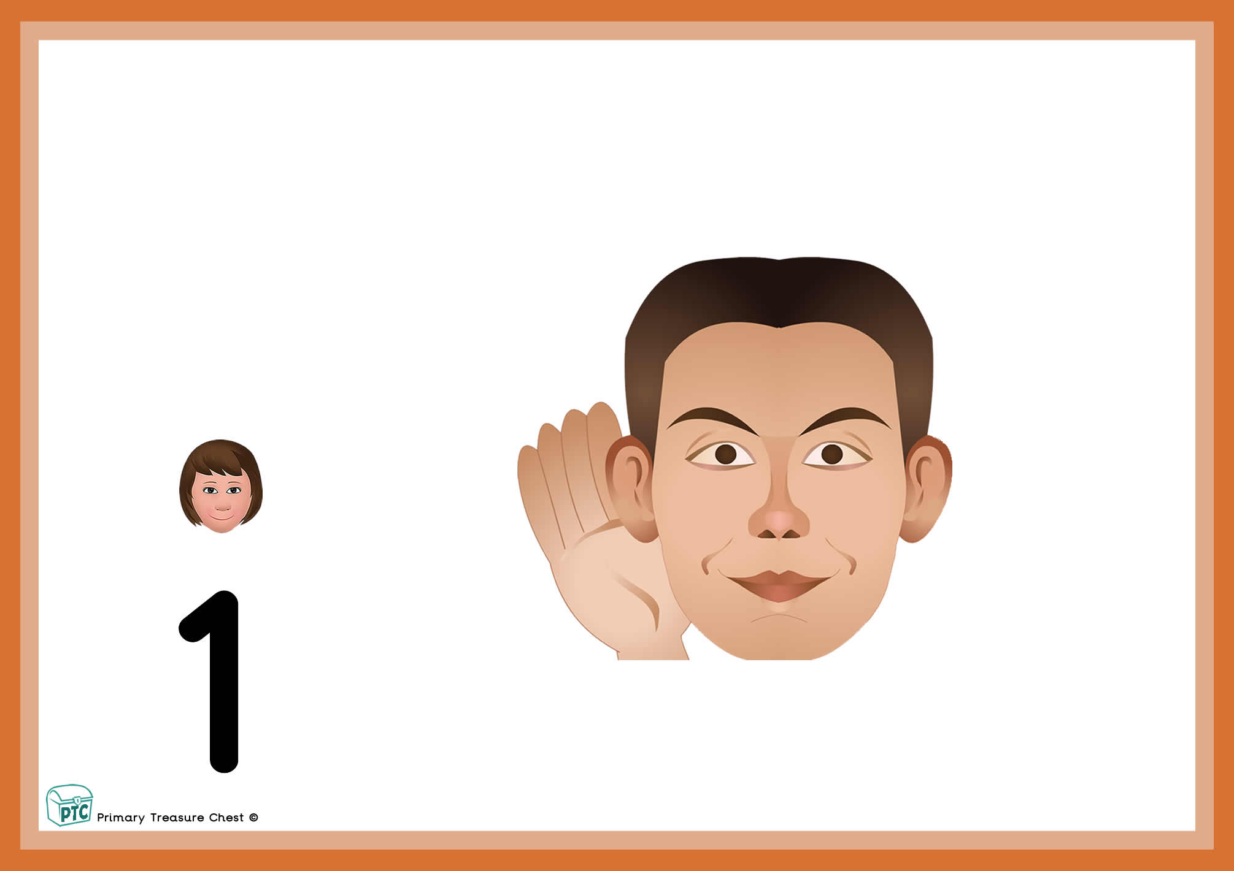

child can play here

Primary Treasure Chest

A Word on Copyright

We thank you for downloading the resources from our website. Designing, creating, updating, uploading and improving these resources takes time, effort and money. That is why there are certain things that you CAN and CANNOT do with these resources.
Once downloaded, you CAN do the following with the resources:
- Use them for your own personal or classroom use
- Reproduce and make copies, but only for your own personal or classroom use
- Create backup copies that are meant to be used for your own personal or classroom use

However, you CANNOT do the following with the resources:
- Reproduce for use by others in any form whatsoever or through any means including, without limitation, electronic, mechanical, photographic, or electrical means
- Distribute freely to others in any form whatsoever or through any means
- Commercially distribute for profit in any form whatsoever or through any means

We trust your intentions and purposes for which you’ve downloaded these resources and expect your endeared cooperation in future too.

In order to keep providing high quality teaching resources, please do not distribute to friends and colleagues but please encourage them to visit our site. The more people who visit the site the more resources we can afford to make.

We would like to take this opportunity to thank all those who have contributed ideas and suggestions for this website. If you have any suggestions or a 'wish list' please contact us and we will do our very best to meet your individual needs.
Many Thanks,
Paul & Zoe

